

Model TMDS61

Active digital video & audio six to one switch, remote controlled

Overview:
The TMDS61 is the most affordable AND most compatible digital video switch available today. At the heart of this product is a cutting edge active TMDS (transition minimized differential signaling) switch instead of the typical DVI or HDMI decoder & encoder. This new technology enables our product to switch and amplify the signals only at the electrical level, while leaving the protocol and encryption levels completely unchanged! The result is a lower cost product which is fully compatible with all current AND future forms of DVI & HDMI. A further benefit is you never need to worry about future HDCP encryption problems or incompatibilities; our switch does not modify the source to display interaction in any way.
The TMDS61 can support the following typical applications
- Switching 3 HDMI & 3 DVI inputs to 1 display/receiver/storage device
- Switching 6 HDMI inputs to 1 display (with 3 HDMI/DVI cables)
- Switching 6 DVI inputs to 1 display (with 3 DVI/HDMI cables)
- Switching 6 digital audio inputs (4 optical, 2 coax) to 1 set of transcoded digital audio outputs (coax and optical)
This unit delivers ultra clean noise performance and has selectable output high frequency amplification for driving long cables. The TMDS61 is also the easiest switch on the market to setup and use. Our proprietary ZeroKey technology allows switching to be performed by any key on any remote. No need for separate remotes or remote programming.
Unit includes
- TMDS61 digital video and audio switch as pictured
- 9V wall power supply
3 year parts and labor warranty
Installation

Please use the following steps to install and setup your TMDS61. If you have any questions, contact your retailer or visit www.video-storm.com for help.

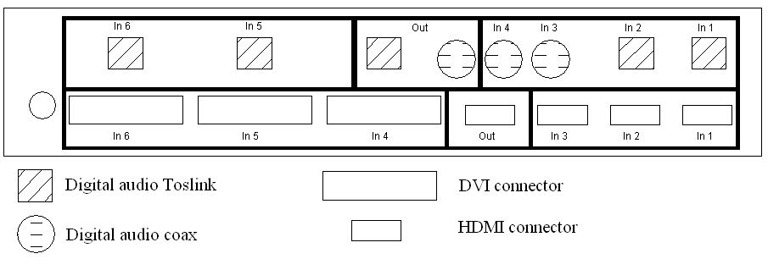

- Connect the DVI inputs to the DVI connectors. Connect the HDMI input to the HDMI connectors labeled “In 1-3”.
- Connect the digital audio inputs to the digital audio coax and toslink inputs labeled “In 1-6”
- Connect the HDMI output to your display. If you have a DVI display, use an adapter of HDMI to DVI cable. Connect either the digital audio coax or toslink output to your receiver.
- Connect the supplied wall transformer to a properly grounded power outlet. Plug into DC input of the TMDS, you should see the LED light on the front panel.

Programming the ZeroKey remote interface
The remote control interface uses ZeroKey infrared code cloning to map any remote control key to each one of the four inputs. Here are the steps to program the TMDS61 for your remote.
- Press the toggle button to select the input you would like to train
- Hold the toggle button for 6 seconds and release
- The LED indicator for the selected channel will now flash continuously, this means it is ready to be programmed
- Aim your remote control at the TMDS61 and press the key you would like to use to select this input
- The LED indicator will stop flashing, this means the code has been stored.
- Repeat for the other inputs
ZeroKey technology is compatible with virtually all remote controls, and does not interfere with the normal operation of the remote. The best way to use this is to program the TMDS61 with the same keys you normally push to switch your AV receiver or TV. The TMDS61 will switch at the same time as your TV or receiver without the need for complicated macros or pushing extra buttons!
ZeroKey programming is stored in flash memory, and you will not need to reprogram even if you lose power. If you buy a new remote in the future, don't worry, the TMDS61 can be reprogrammed as much as you like.
LED indicator
The LED display on the front panel of CSW62 indicates which input is currently selected. It also displays autoswitch, boost, and code clear options. The following table shows what each digit means. The period column refers to the lower right hand dot.
LED | Period
1-6 | Off | Input X is selected, boost is off
1-6 | On | Input X is selected, boost is on
A | On | Auto switch on, no inputs active
A | Off | Auto switch off (hold to active)
C | Off | Zerokey code clear (hold to active)

Auto switch

Auto switching of all inputs can be activated by selecting “A” and holding the button for 3 seconds. When the button is released, the TMDS61 will automatically switch to the first active input in the following order of priority: 1, 4, 2, 5, 3, 6. If no input is active, the LED will display “A.”. You can turn off autoswitch by pressing the front panel button or switching via IR remote. NOTE: autoswitch is not compatible with 100% of DVI/HDMI sources. Some sources remain active even when the power is switched off. If you encounter this, use the lowest priority setting of use IR or front panel switching.

Boost mode

Boost mode should be used whenever the total input and output cable length is greater than 10 ft. Select boost mode for each input by selecting the input with the “period” indicator on. Boost mode is used to compensate for cable loss, and is not necessary unless you see image degradation without it.

Specifications
- 6 Digital video inputs
3 HDMI style connectors
3 DVI style connectors
All inputs compatible with both DVI or HDMI signals
Tested to 1080p HDTV resolution
- 1 Digital video outputs
HDMI style connector
Compatible with both DVI or HDMI displays
Selectable high frequency boost mode for driving long cables
- 6 Digital audio inputs
4 optical audio connectors
2 coaxial (rca) audio connectors
- 1 Set of digital audio outputs
1 optical and 1 coaxial connectors (both active)
Transcoding selected digital audio, optical => coax & coax => optical
- Auto switching option for digital video switching
- HDCP, CEC, and audio pass-through compatible
TMDS only switching provides maximum compatibility
- Internal design
Flash programmable micro controller enables ZeroKey remote technology
1.65 Gbps differential sampling amplifiers provide excellent signal switching and propagation
High reliability capacitors and self resetting fuse protection for long life
Designed and manufactured in the USA
- Housing
Black powder coated aluminum housing 9.5" x 3.4" x 1.9"
Warranty

When you receive your shipment, immediately inspect the package for shipping damage. While it is extremely rare for shipping damage to occur, if your package is damaged notify the shipping company AND the retailer of the damage within two days. If shipping insurance has been purchased, you will be reimbursed by the shipping company for the damaged item. However, it is your responsibility to notify both parties within two days of receiving the damaged item.

Video Storm LLC products are covered by our manufacture’s warranty. Our warranty covers parts and labor for 3 years following purchase. In the unlikely event you receive an item that was not damaged in shipping but is defective please contact support@video-storm.com and we will repair or replace the item promptly.

