

Model CSM42

Ultra Wide bandwidth HDTV, digital audio, and analog audio matrix switch & distribution amplifier with ZerokeyTM technology

Overview:
The CSM42 is the only product on the market, under $1000, which can deliver full quality HDTV matrix switching! It is also the most feature rich matrix switch available, combining HDTV video, analog audio, coax & optical digital audio, digital audio transcoding, and distribution capable output drivers. Don't settle for an inferior product which will degrade your signals.
Matrix switching capability means that both outputs are independently controllable. They may display the same input or different inputs.
Digital audio transcoding means that coax digital audio can be converted to optical (TOSLINK) digital audio, and vice versa. Selector switch or remote control can select the direction of conversion, which can be independently controlled for both outputs.
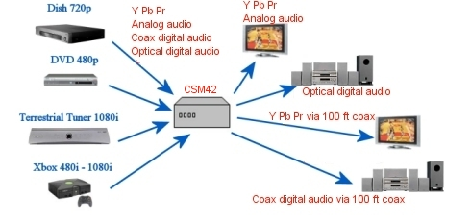
The CSM42 can support the following typical applications:
- Switching 4 sets component video & analog audio to 2 displays/receivers/storage devices
- Switching 4 sets component video & digital coax audio to 2 displays/receivers/storage devices
- Switching 4 sets component video & digital optical audio to 2 displays/receivers/storage devices
- Transcoding/converting Digital audio between coax and optical
This unit delivers ultra clean noise performance and more bandwidth than needed for all high definition video standards. The CSM42 is also the easiest component switch on the market to setup and use, and it supports all HDTV video and audio formats Our proprietary ZeroKey technology allows switching to be performed by any key on any remote. No need for separate remotes or remote programming. The CSM42 is the optimal solution for all these applications, and the specs speak for themselves.
Unit includes
- CSM42 component video & audio matrix switch & distribution amplifier as pictured
- 12 HDTV component video inputs, 6 outputs (Inputs: 4 switched sets of 3; Outputs: 2 sets of 3)
- 8 Analog audio inputs, 4 outputs ((Inputs: 4 switched sets of 2; Outputs: 2 sets of 2)
- 4 Digital audio inputs, 2 outputs
- 4 Optical audio TOSLINK inputs, 2 outputs
- 9V wall power supply
- 3 year warranty
Installation

Please use the following steps to install and setup your CSM42. If you have any questions, contact your retailer or visit www.video-storm.com for help.

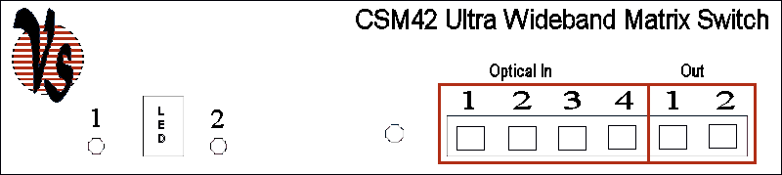
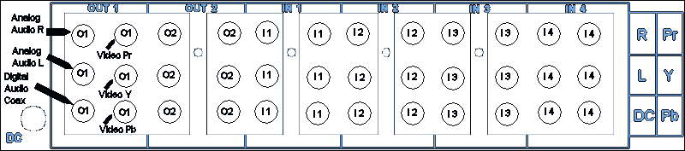

Each input and output set on the CSM42 contains the following connectors
- Component video (Pr Y Pb or Red Green Blue)
- Analog audio (R & L)
- Digital audio coax (DC)
- Digital audio optical/TOSLINK (on front panel)

- Connect the video inputs and outputs. For component video, match the cable colors to the red/green/blue video inputs & outputs. For composite video, you may use any set.
- Connect the digital and analog audio inputs and outputs.
- Connect the supplied wall transformer to a properly grounded power outlet. Plug into DC input of the CSW02, you should see the LED light on the front panel.

Controlling the CSM42
Each of the output sets is independently controllable.
Selector switch 1 is used to control output set 1
Selector switch 2 is used to control output set 2

The LED will display the selected input for the most recently switched output. The “dot” in the lower right corner indicates output 2. If the dot is not present, output 1 is being displayed. When an input is selected via selector switch or remote control, the LED will first show the input set number (1-4), then briefly show the digital audio type (C for coax, O for optical). Analog audio is always on. The selector switches will toggle through all choices (8 total for each output). The remote control can select any mode directly.

Example 1: When the LED displays 2, then C, then 2 with no dot in the corner
  - Output 1 is connected to input 2.
  - Output 1 digital audio (optical & coax) are transcoded from input 2 digital coax

Example 2: When the LED displays 4, then O, then 4 with a dot in the corner
  - Output 2 is connected to input 4.
  - Output 2 digital audio (optical & coax) are transcoded from input 4 digital optical
Programming the ZeroKey remote interface
The CSM42 switch can be controlled manually by toggle button, or by remote control. The remote control interface uses ZeroKey infrared code cloning to map any remote control key to each one of the four video & audio inputs. Here are the steps to program the CSM42 for your remote.
- Press the toggle button to select the input/output pair you would like to train
- Hold the toggle button for 3 seconds and release
- The LED indicator for the selected channel will now flash continuously, this means it is ready to be programmed
- Aim your remote control at the CSM42 and press the key you would like to use to select this input
- The LED indicator will stop flashing, this means the code has been stored.
- Repeat for the other input/output pairs (up to 16 total).
ZeroKey technology is compatible with virtually all remote controls and does not interfere with the normal operation of the remote. The best way to use this is to program the CSM42 with the same keys you normally push to switch your AV receiver or TV. The CSM42 will switch at the same time as your TV or receiver without the need for complicated macros or pushing extra buttons!
ZeroKey programming is stored in flash memory, and you will not need to reprogram even if you lose power. If you buy a new remote in the future, don't worry, the CSM42 can be reprogrammed as much as you like.
Specifications
- 12 HDTV component video inputs with: 75Ohm terminated at all frequencies, Gold plated matched low impedance RCA jacks, 1Vpp nominal input swing (Ypbpr) or 1.3Vpp (Cvbs) 2.5Vpp maximum, Crosstalk < -80 dB.
- 6 HDTV component video outputs with: Source impedance 75 Ohms, Gold plated matched low impedance RCA jacks, AC coupled to protect all connected equipment, Both output sets individually controllable/switchable, High performance amplifier capable of driving over 100ft of coax cable per output, Noise spectrum > 60 dB, -3dB bandwidth > 200 Mhz.
- 8 Analog audio inputs + 4 analog audio outputs: All use gold plated matched low impedance RCA jacks. Both output sets are individually controllable/switchable. Analog audio outputs support soft switching to eliminate pops & clicks when switching.
- 4 Coax Digital audio inputs + 4 Optical Digital audio inputs: Coax digital audio inputs are gold plated matched low impedance RCA jacks. Optical digital audio inputs have built in shutters.
- 2 Coax Digital audio outputs + 2 Optical Digital audio outputs: Coax digital audio outputs are gold plated matched low impedance RCA jacks. Coax digital audio outputs are AC coupled to protect all connected equipment, and capable of driving over 100ft of cable. Optical digital audio outputs have built in shutters. Transcoding of selected digital audio, optical => coax & coax => optical. Both output sets are individually controllable/switchable.
Warranty

When you receive your shipment, immediately inspect the package for shipping damage. While it is extremely rare for shipping damage to occur, if your package is damaged, notify the shipping company AND the retailer of the damage within two days. If shipping insurance has been purchased, you will be reimbursed by the shipping company for the damaged item. However, it is your responsibility to notify both parties within two days of receiving the damaged item.

Video Storm LLC products are covered by our manufacture’s warranty. Our warranty covers parts and labor for 3 years following purchase. In the unlikely event you receive an item that was not damaged in shipping but is defective please contact support@video-storm.com and we will repair or replace the item promptly.

